Russ Lammermeier and MaryBeth Matthews Max S. Hayes High School C.M.S.D.
May, 2012 Grade: 12

Topic: WPA in Cleveland
Unit: The Art of the New Deal in Cleveland

Art Standards:
- Understand the reciprocal influence of arts and society.
- Generate original ideas through the arts
- React and respond to works of art through an informed personal perspective.
- Understand the variety of cultural, philosophical and historical perspectives that define works of art

Social Studies Standards:
- History: Identify major historical patterns in the domestic affairs of the United States during the 20th century and explain their significance.
- Economics: Explain how the U.S. government provides public services, redistributes income, regulates economic activity, and promotes economic growth and stability.
- Skills and Methods: Evaluate the reliability and credibility of sources.

Art Objectives:
- Students will study images of genre drawings made by WPA artists in Cleveland and describe the characteristics and qualities of the work from an informed historical perspective.
- Students will produce a conte/charcoal drawing of people at work in the style of Cleveland WPA artists.

Social Studies Objectives
- Students will be able to explain how the WPA was active in Cleveland during the Great Depression.
- Students will have an understanding of the various forms of art produced by the WPA and how art was used to promote the ideology of the New Deal.

Materials:
- Textbook- read overview of the Great Depression
- You-tube video regarding the WPA and links to various sites of WPA art
- Digital cameras
- Sketchbook
- Pencil/eraser
- Bristol board or illustration board 12” x 24”
- Conte crayon or charcoal pencils/sticks

Rationale:
Students will have a working understanding of the significance of the WPA, during the Great Depression, in Cleveland. They will better understand this time through the art that was produced by local artists hired by the WPA. They will also make the connection about how art plays a significant role in providing information and swaying viewers.

Local Resources: Cleveland State Memory Archives, Western Reserve Historical Society Library
Various local online sites including:
Cleveland Art and History
http://www.clevelandartandhistory.org/
Cleveland Artist Foundation, WPA Site
http://www.clevelandartists.org/?subject=wpa&sub=index
Encyclopedia of Cleveland History, Work Projects
http://ech.case.edu/ech-cgi/article.pl?id=WPA1
Black Art in America
http://blackartinamerica.com/video/wpa-artist-charles-sallee
Youtube
https://www.youtube.com/watch?v=fWx0jZkuuP0

Materials gathered from this resource: Historic Information and Images used in powerpoint presentation

Procedure
Anticipatory Set: (connecting Cleveland to students’ broader coarse of study)
- Students will have Studied the Great Depression and FDR’s New Deal
- Students will have background knowledge in art elements and design principals relating to composition, as well as technical working skills in the medium (charcoal or conte crayon)

Steps: (What will you do? What will they do?)
- Students will read articles on the WPA in Cleveland printed from these websites: Cleveland Art and History, The Cleveland Artist Foundation, and The Encyclopedia of Cleveland History.
- Teachers will present a powerpoint (including Youtube videos) covering an overview of the WPA , it’s economic impact on Cleveland, and the work of several Cleveland WPA artists including: Charles Sallee (The Post Setters), Kalman Kubinyi (Railroad Crossing, Lakefront), and Dorothy Rutka (Poverty, Eviction). Matthew Daniels (No Help Wanted) *
- Students will write an essay using the following questions as writing prompts: What do the images created by the artists tell you about life in Cleveland during the 1930’s? How would you describe the style used by the Cleveland WPA artists?

- Students will take digital photos of people at work. (Labor type jobs are best for this assignment)

...Continued

- Using the digital photos as visual reference sources, students will create a rough draft of their composition.
- Students will use either charcoal or conte crayon to produce their composition on Bristol or illustration board.

Closure:
- Teachers will lead a class critique of the student artwork created in this unit.
- Students will write an Artist Statement including the following components:
What is the title of your work? What is the message you want to convey to the viewer? How did you come up with the idea? Describe your artwork. What did you learn from this project. If given the opportunity, is there anything you would do differently?

Reflection: From what you have learned in the articles, slides, and video presentations of Cleveland WPA, how would you compare or contrast 1930’s Cleveland to Cleveland today?

* See Images of Artwork Below

WPA Cleveland Images

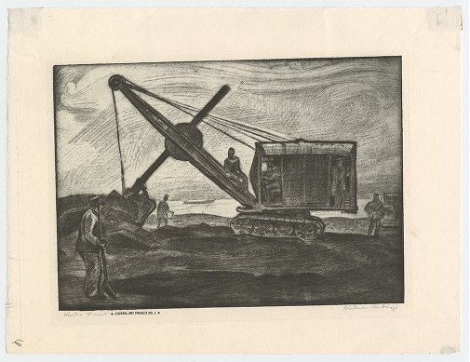
Kalman Kubinyi: Lakefront
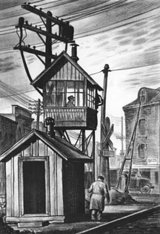
Kalman Kubinyi: Railroad crossing

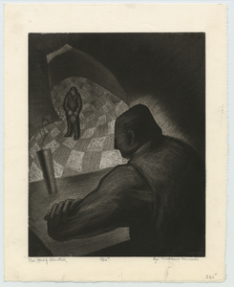
Mathew D. Daniels: No Help Wanted

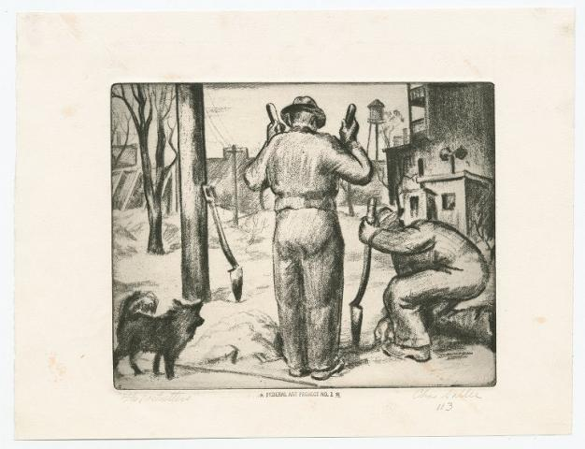
Charles Sallee: The Post Setters

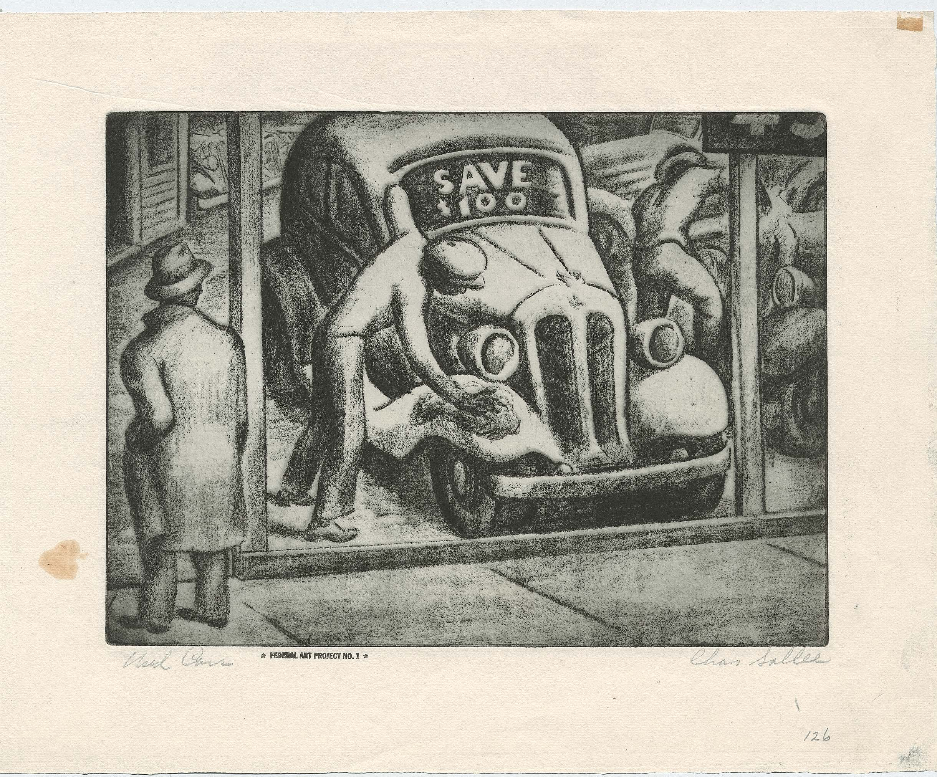
Charles Sallee: Used Cars

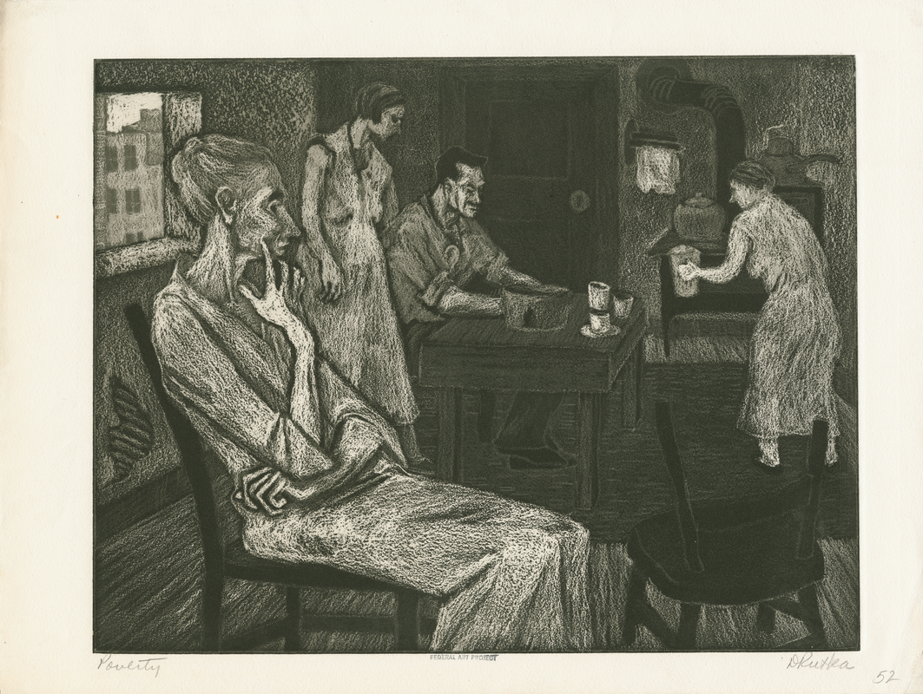
Dorothy Rutka: Poverty

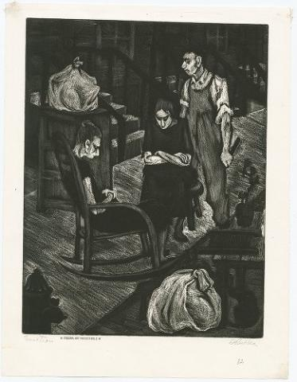
Dorothy Rutka: Eviction

